**Project1 - Microsoft Windows Server 2019 Base**

**Step1 – Connect to server**

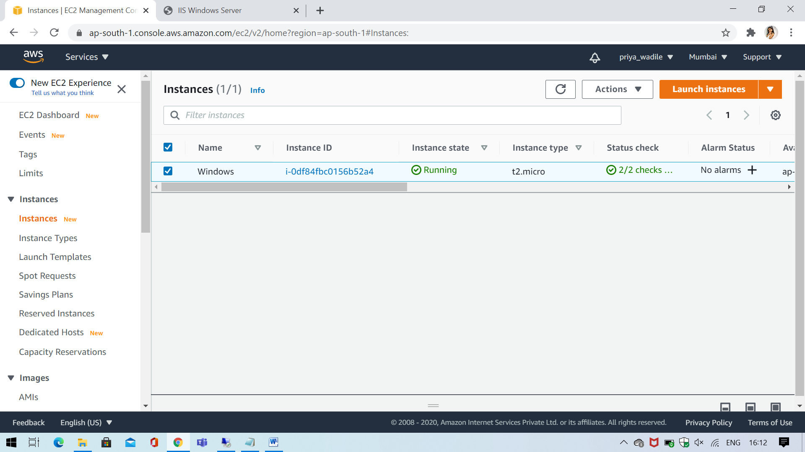

**Step2- Running IP**

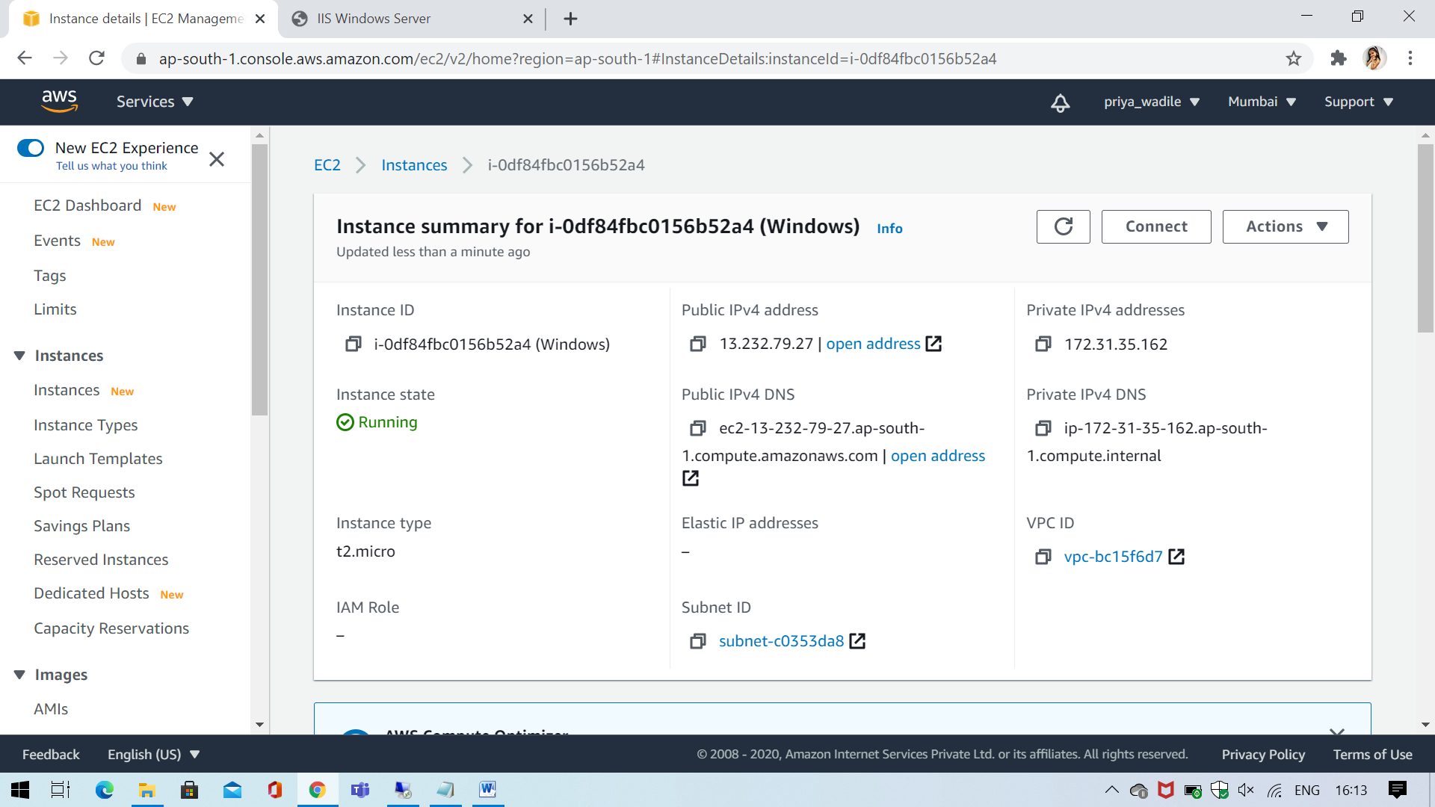

**Step3 - Web-Server Launch**

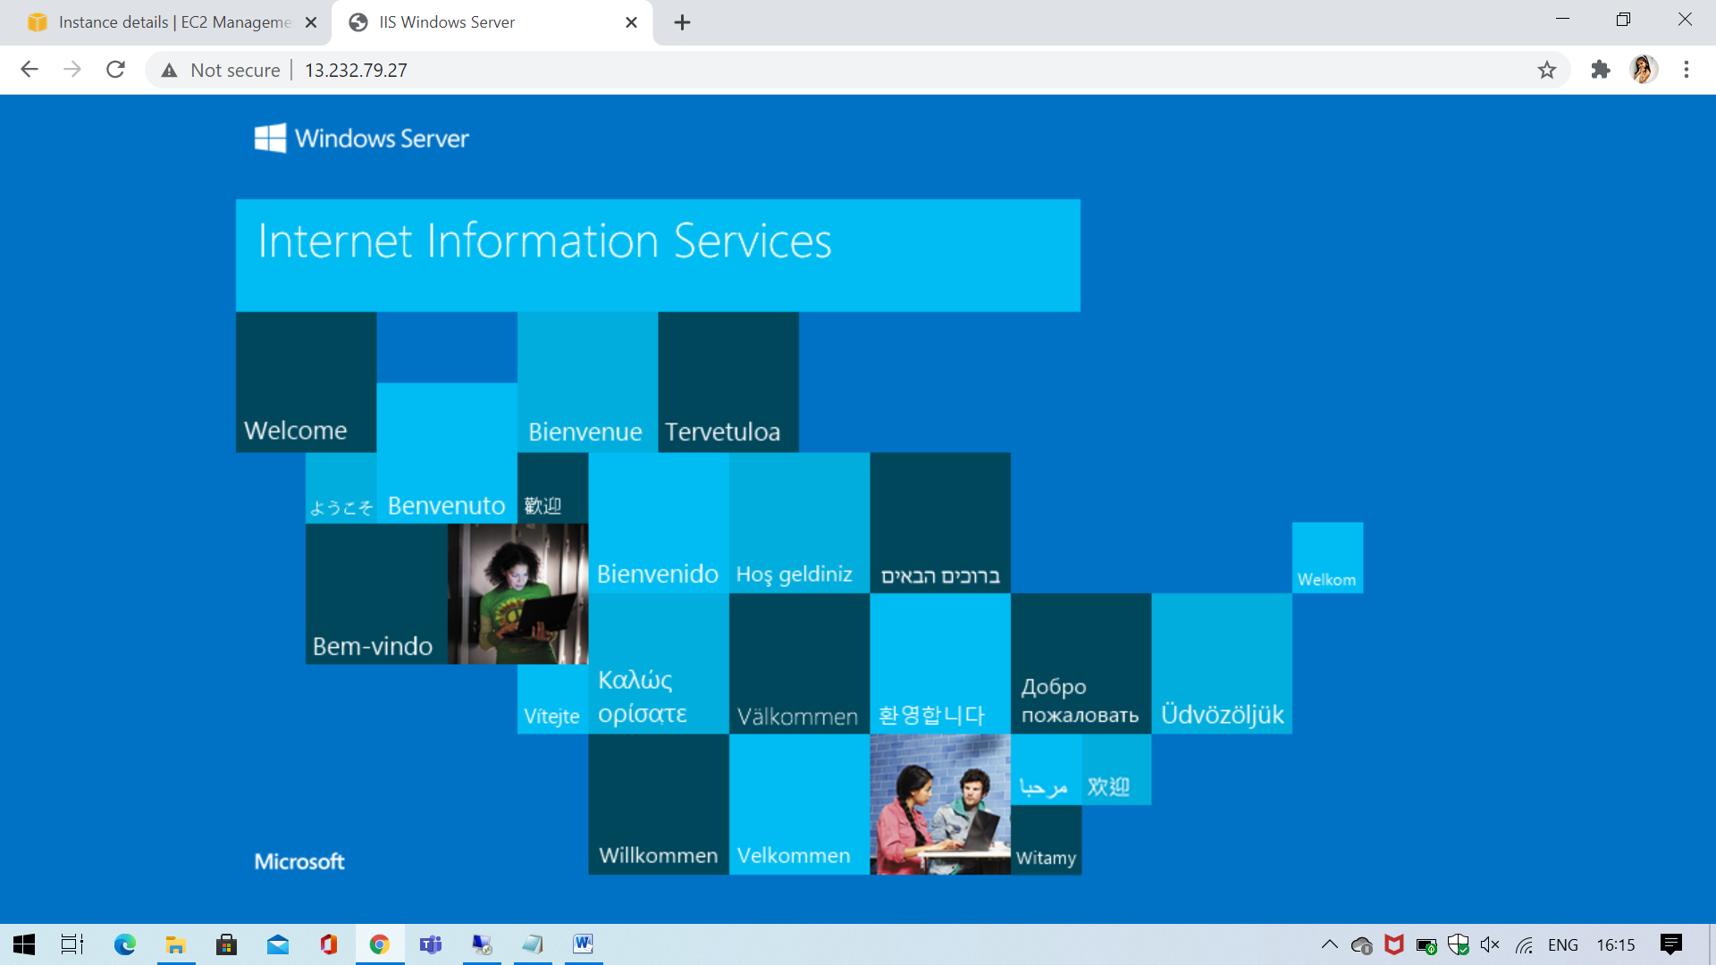

**Project2 - Ubuntu Server 20.04 LTS (HVM), SSD Volume Type**

**Step1 – Connect to server**

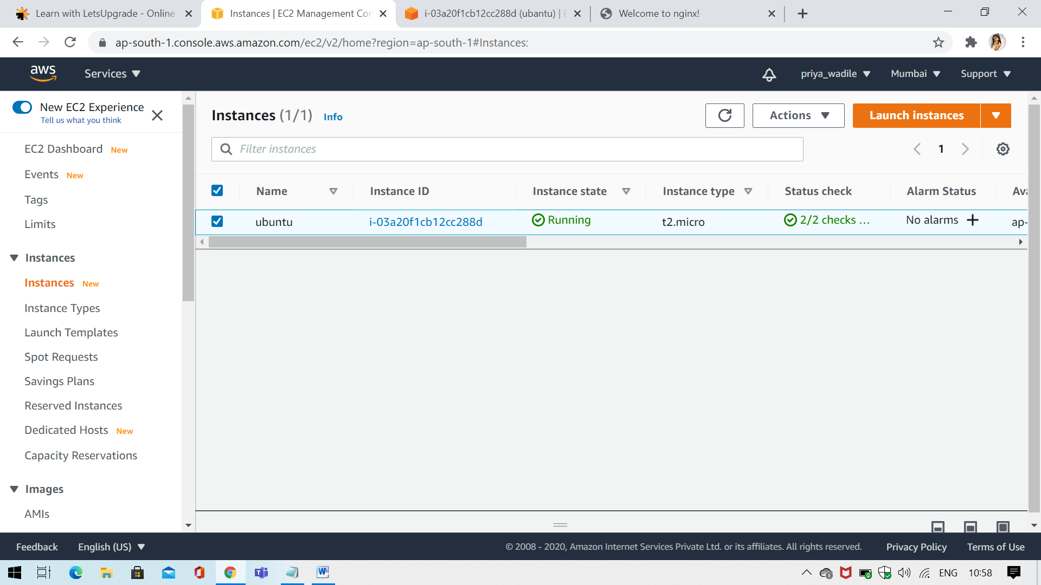

**Step2- Running IP**

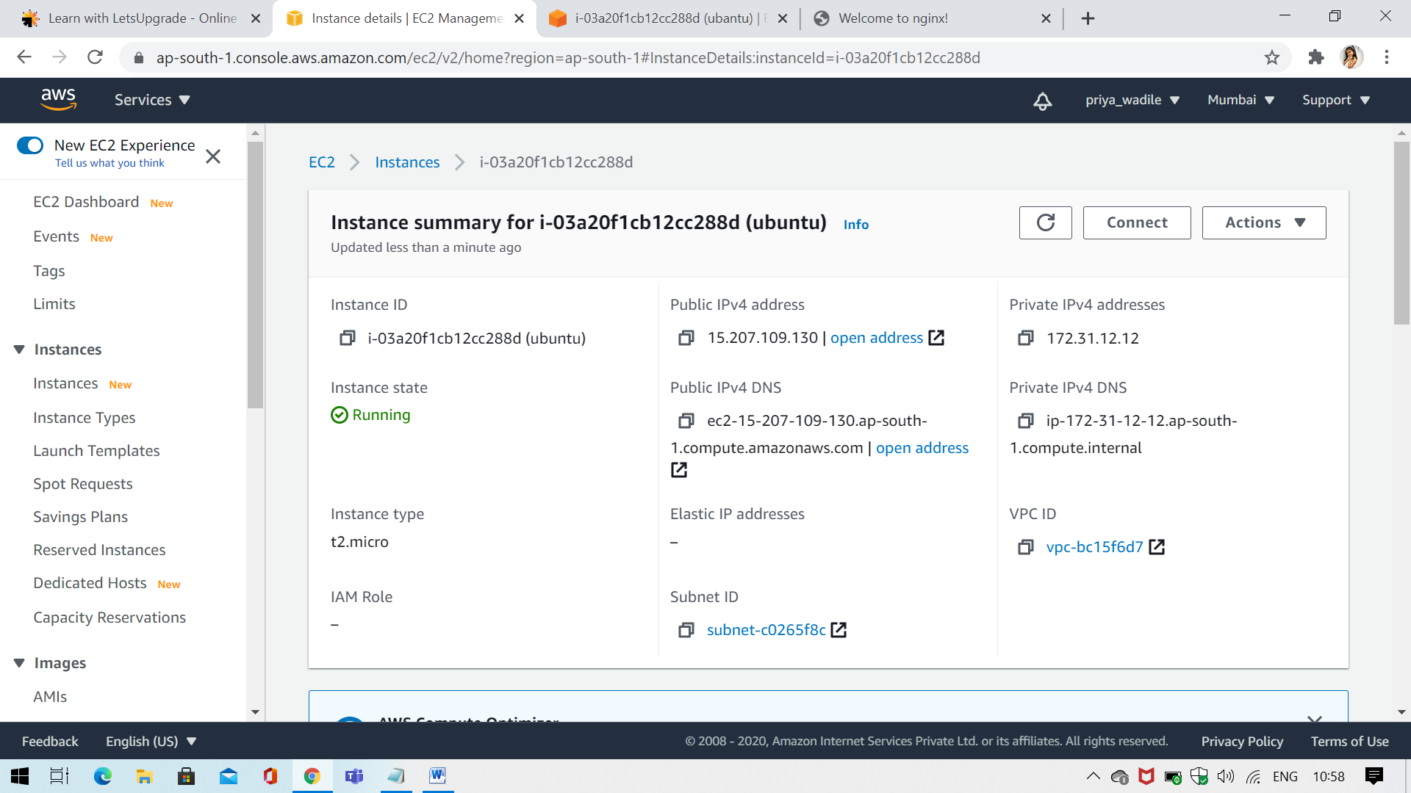

**Step3 - Web-Server Launch**

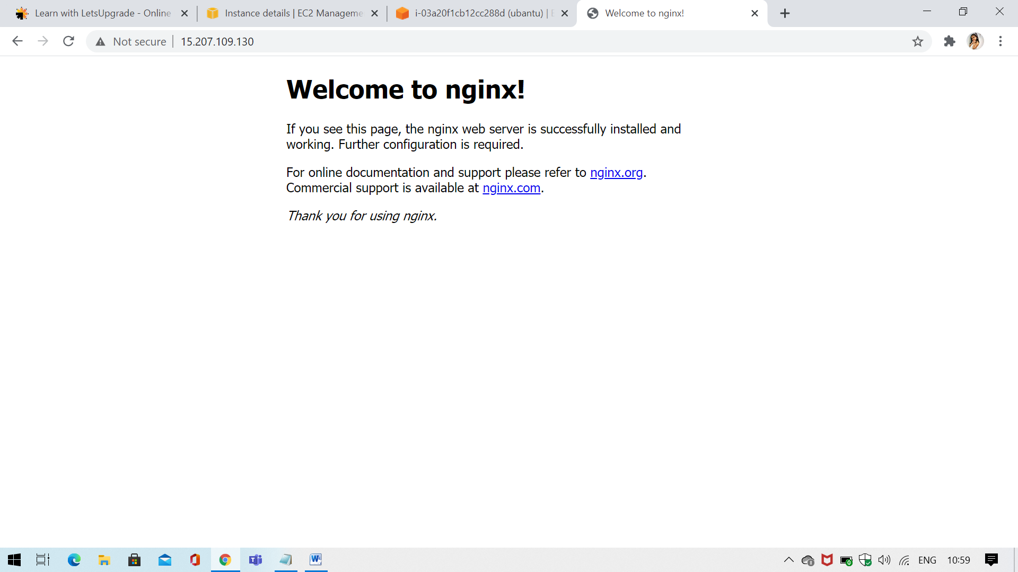

**Project3- Working with Volumes**

**Step1 – Connect to server**

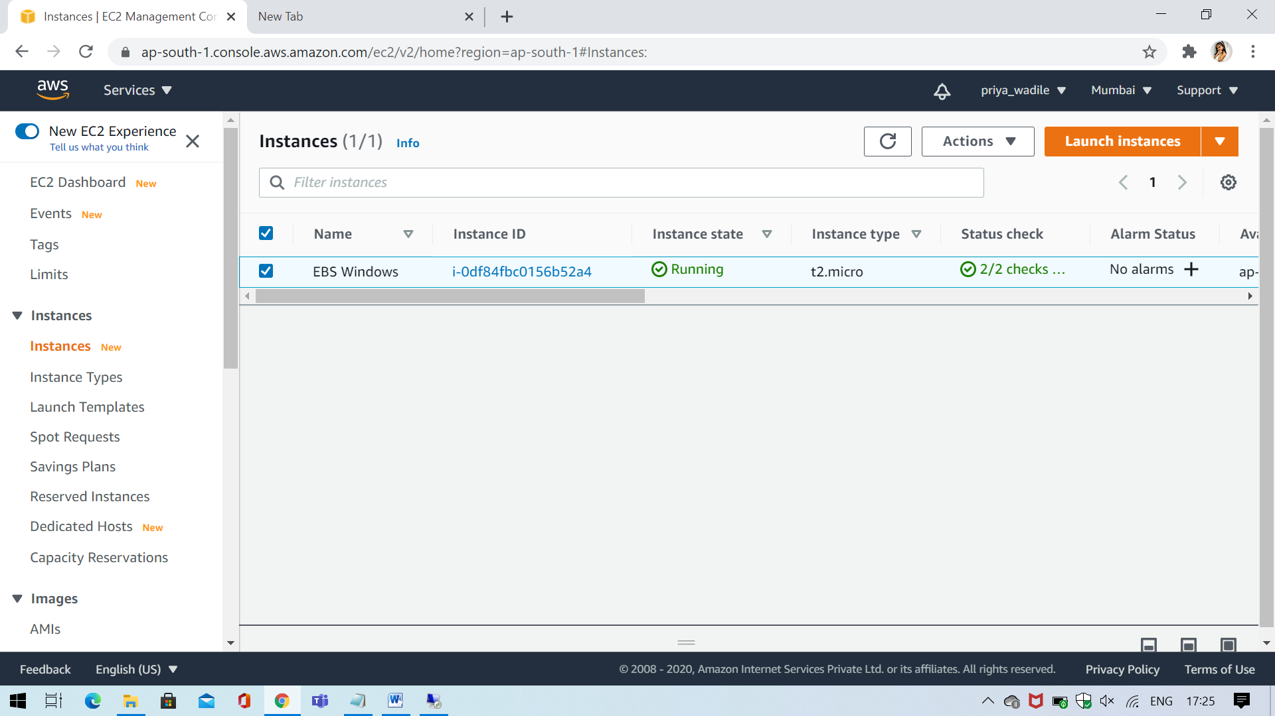

**Step2 - Create a volume in the same region as the windows machine**

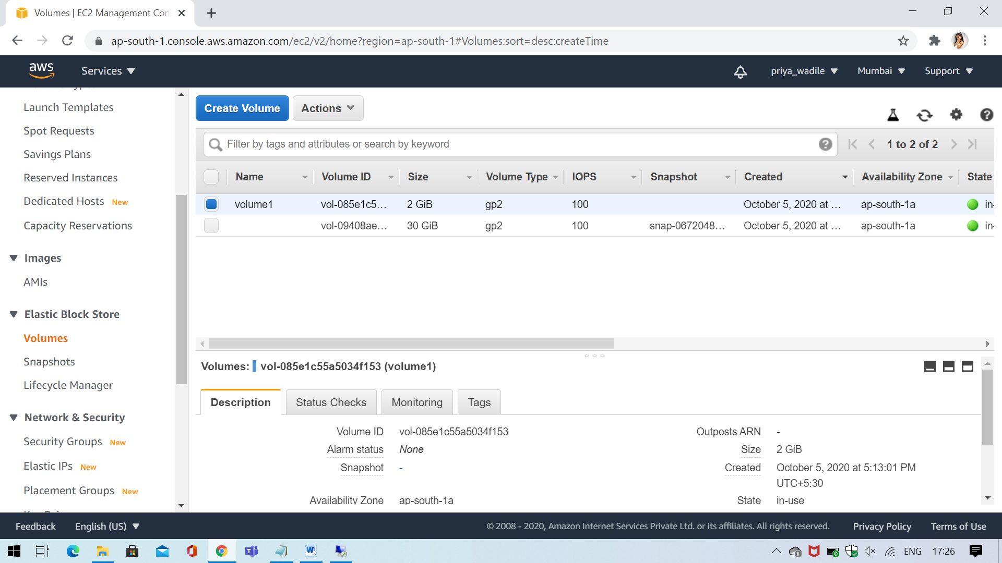

**Step3- From server manager bring the volume online**

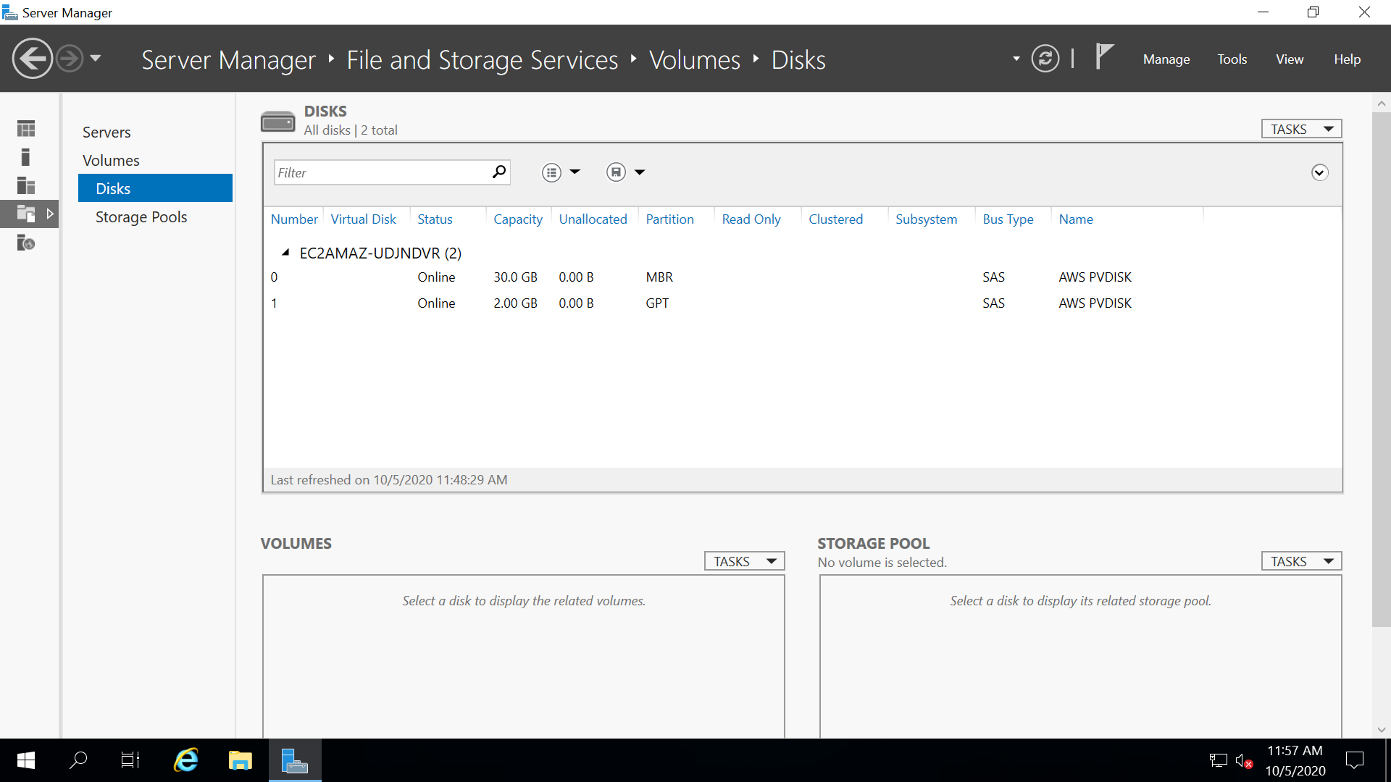

**Step4 – Create D Drive**

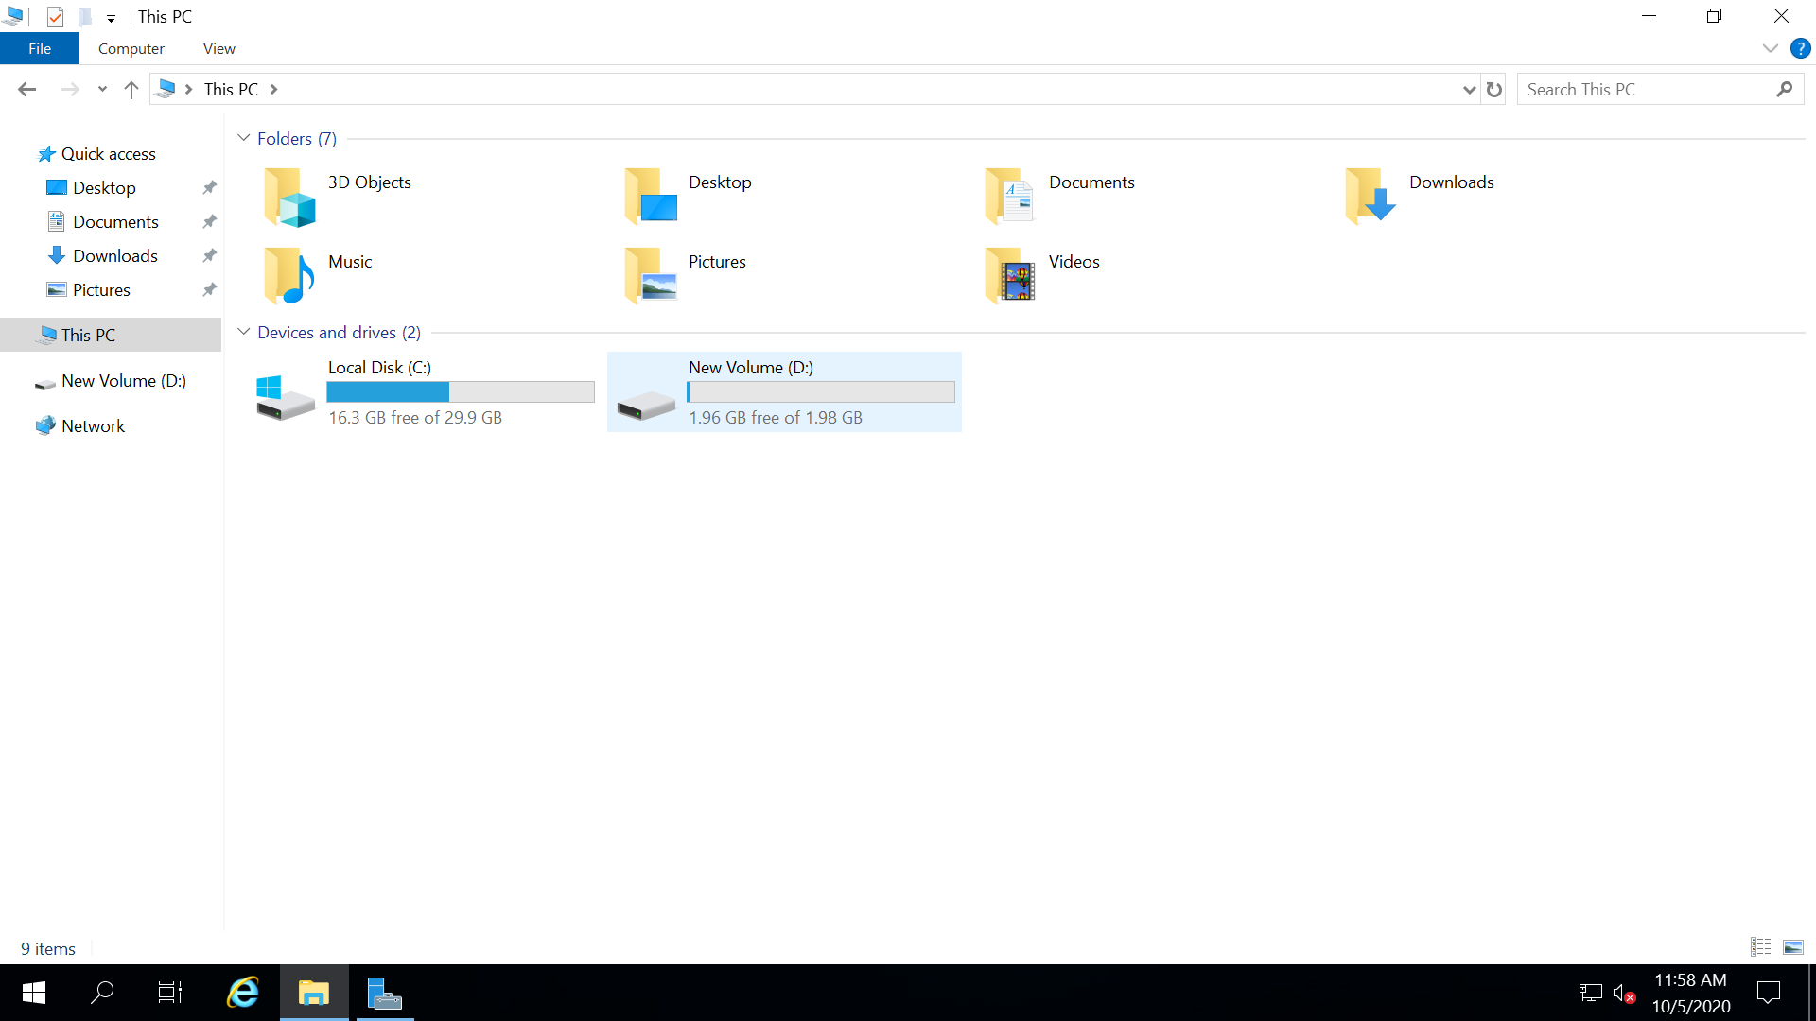

**Project4 - Working with Elastic IP's**

**Step1 – Connect to server**

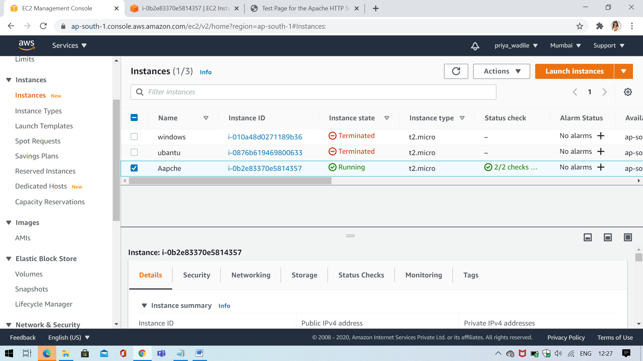

**Step2 – Running IP**

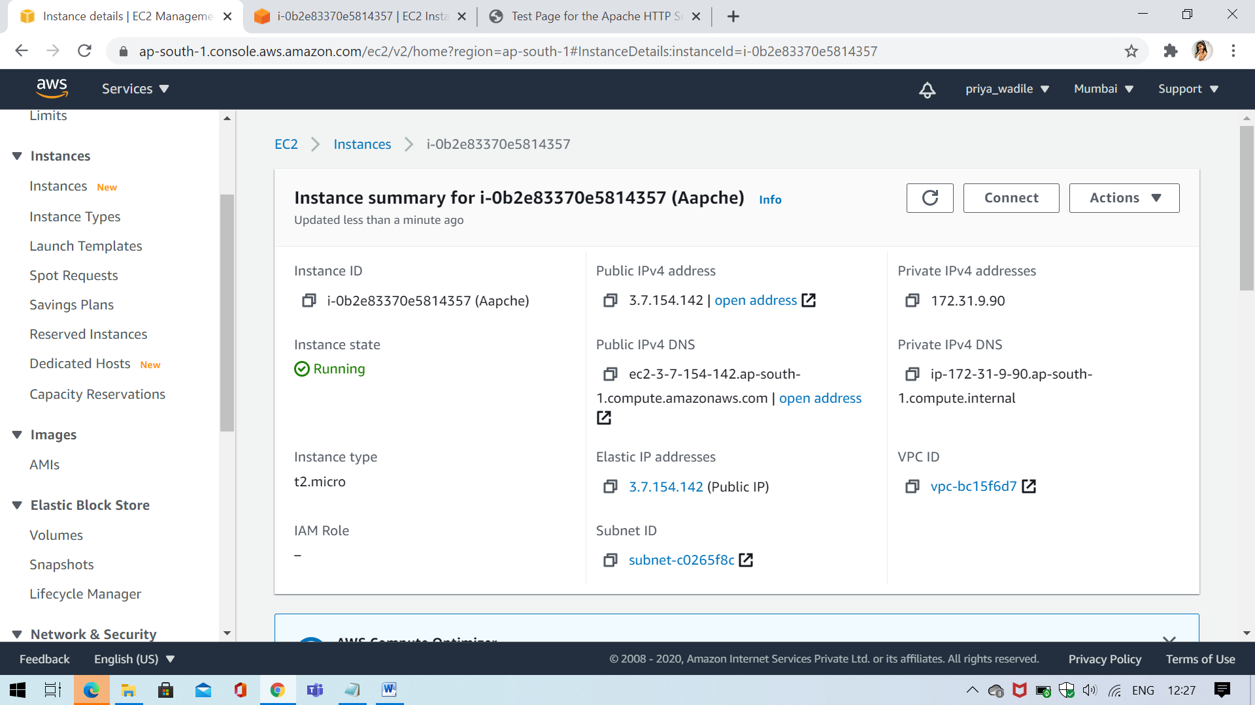

**Step3 – Apache server**

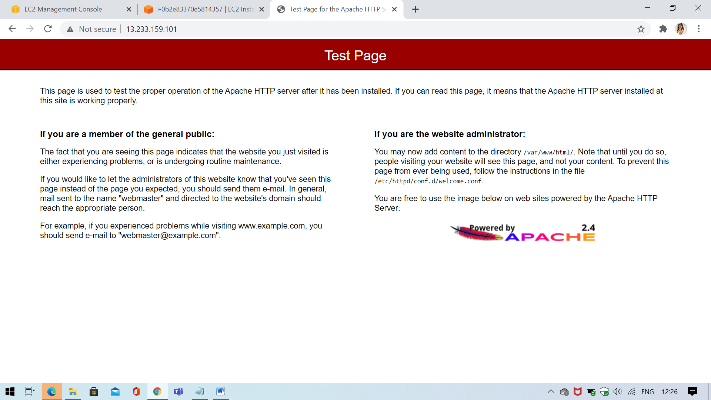

**Step4 – Create Elastic IP**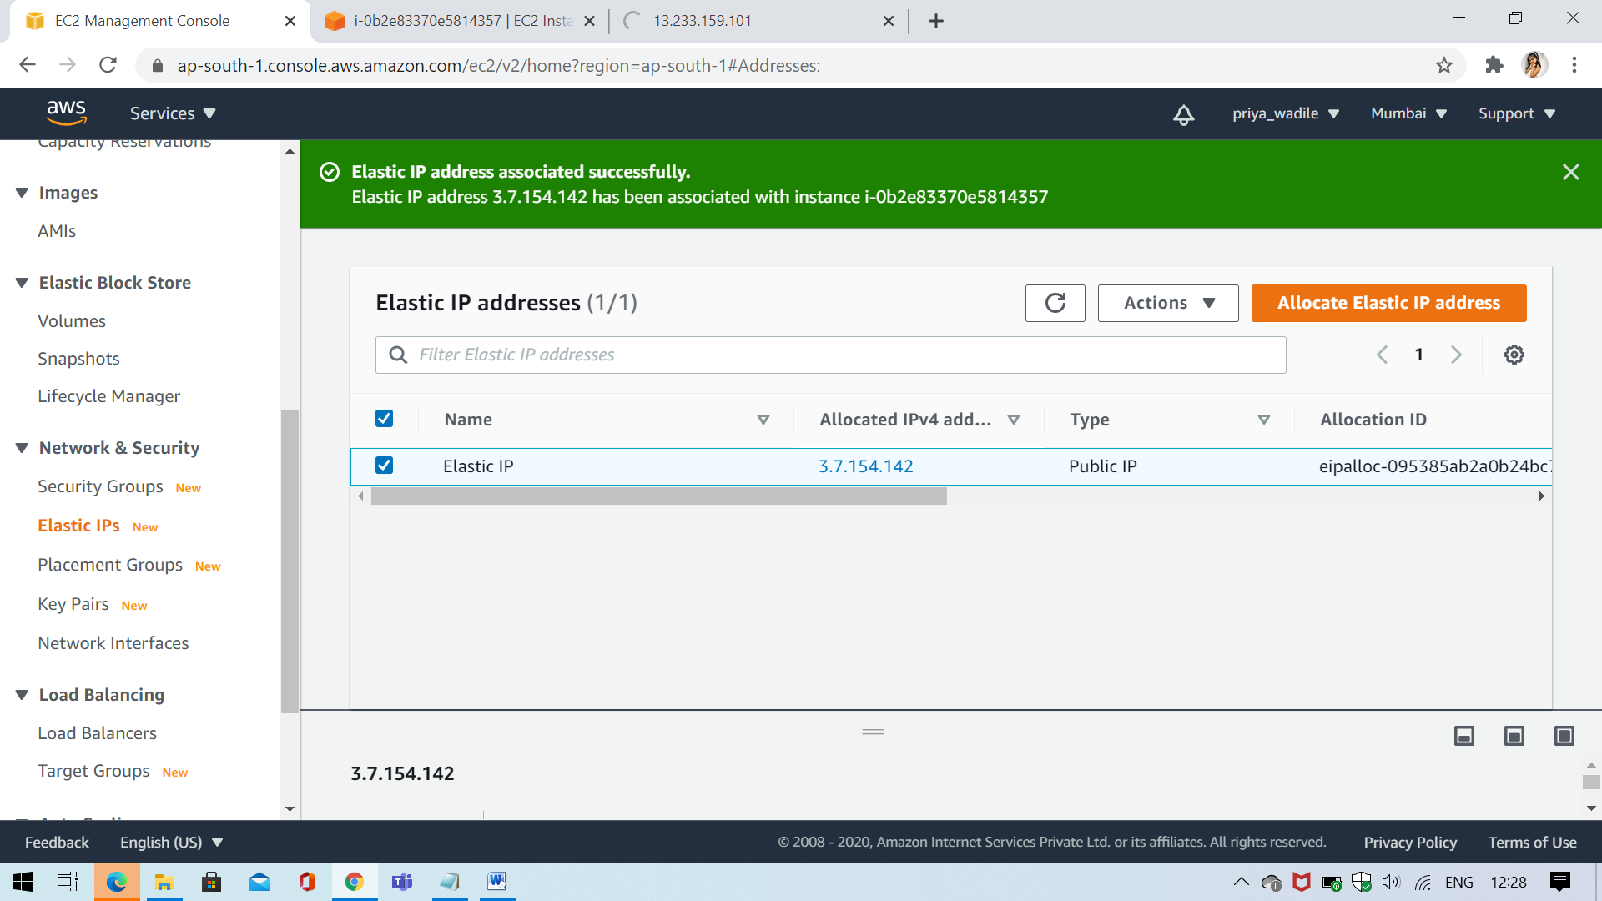

**Step5 – Reload the page**

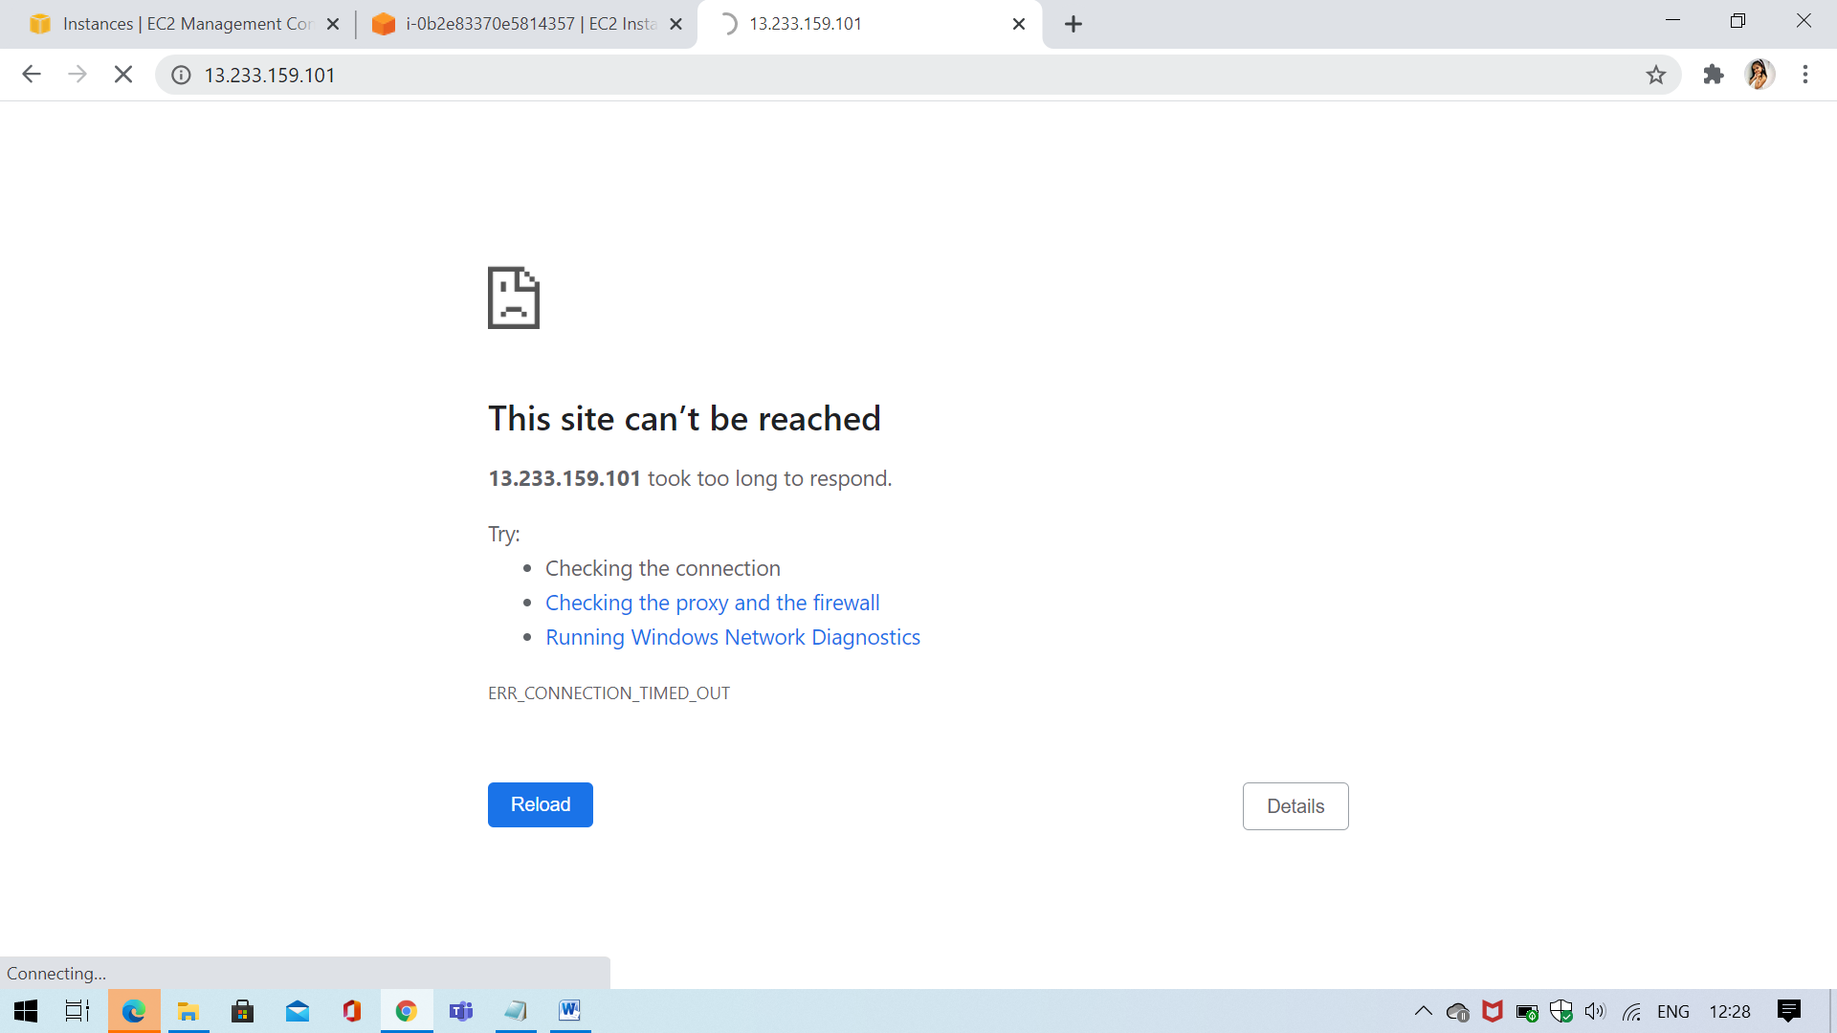

**Step6 – IP Address change**

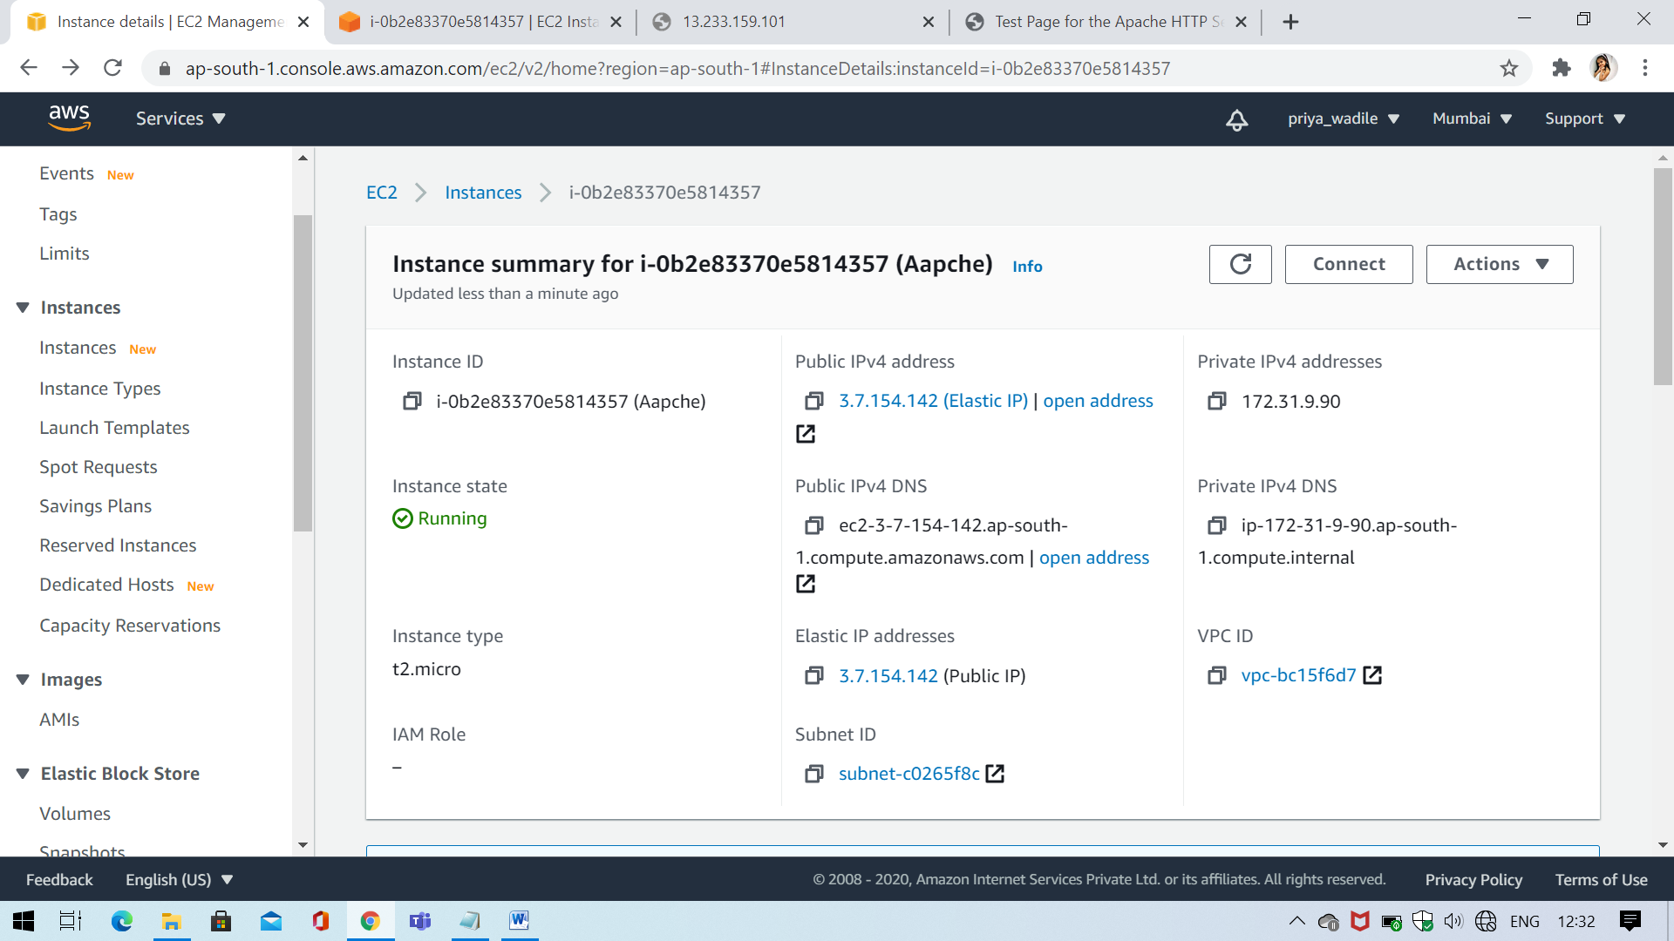

**Step7 – New IP address**

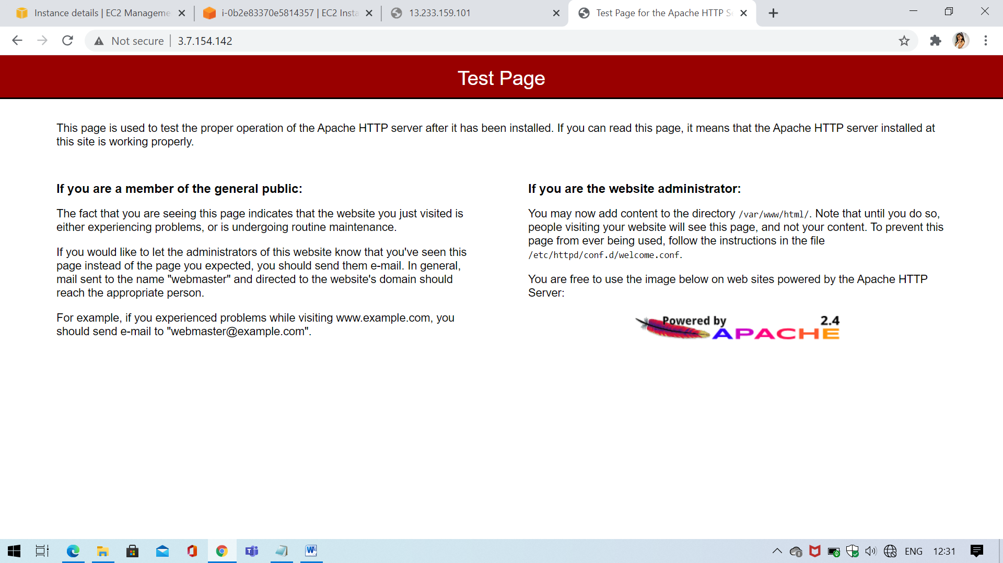

**Project1 - Working with S3**

**a.working with S3-.jpg**

**Step1 – Create S3 Bucket**

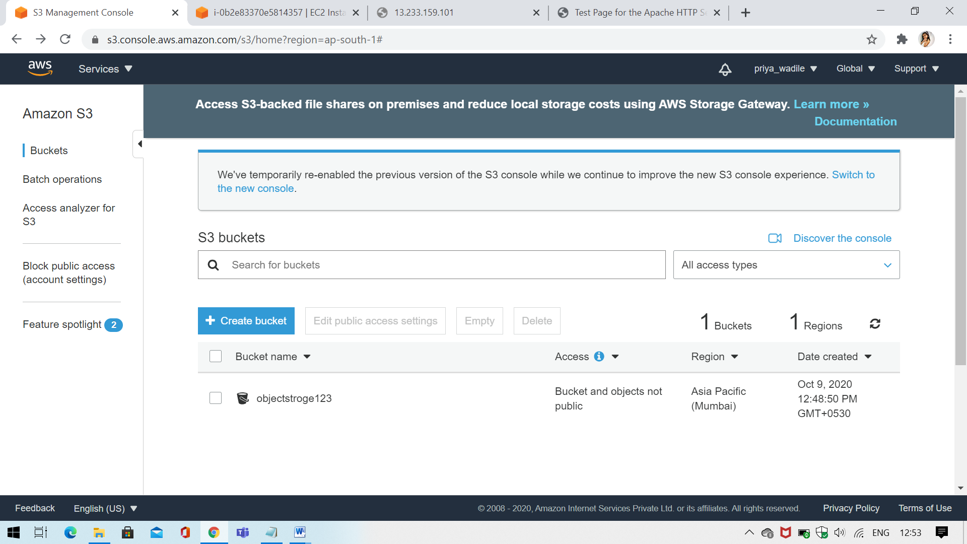

**Step2 – Upload Image**

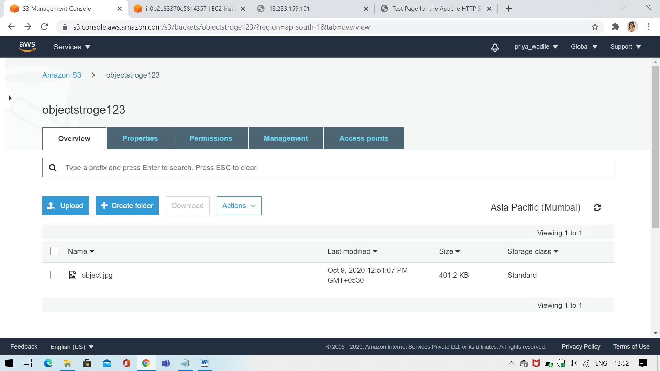

**Step3 – Open url**

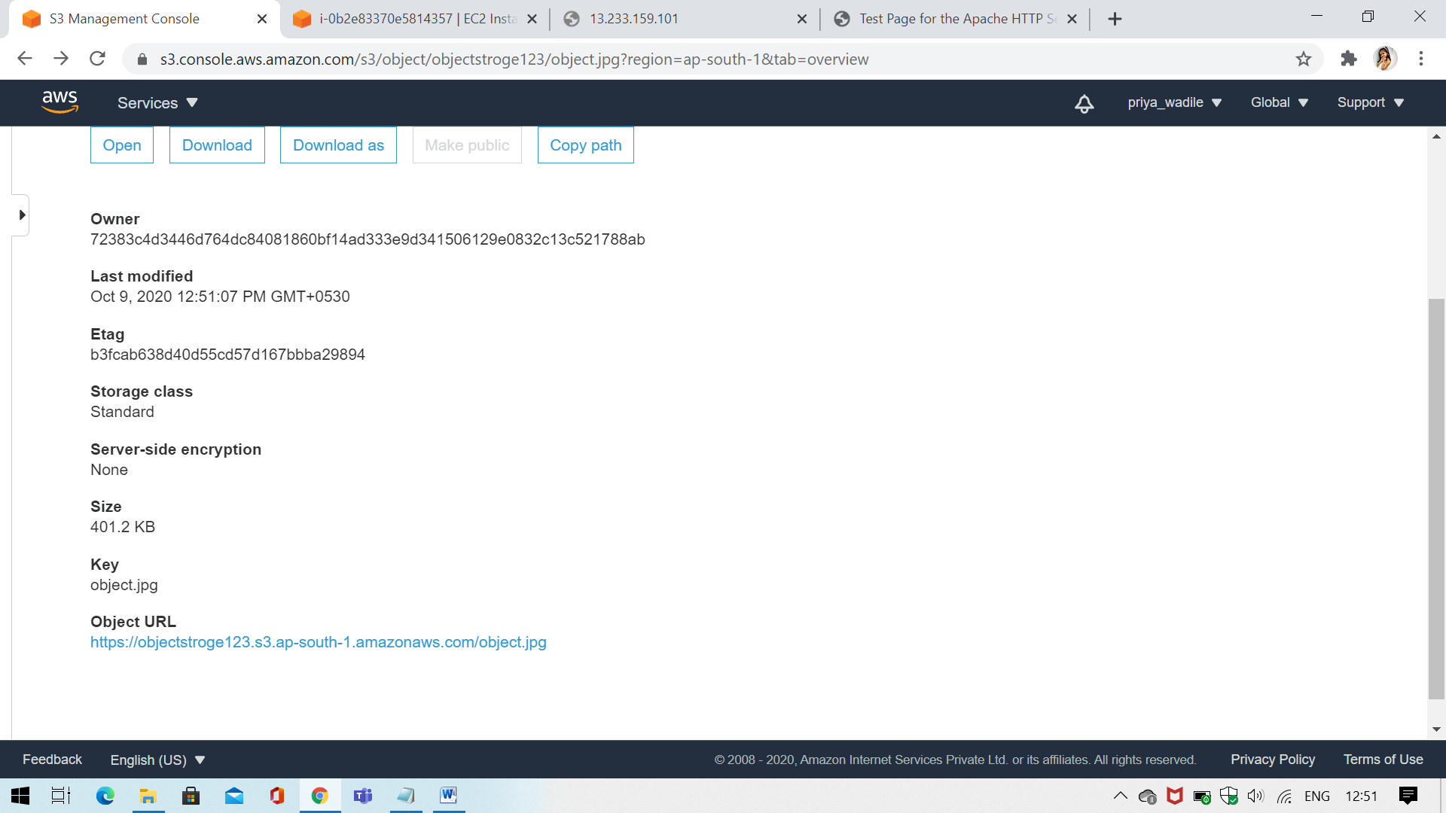

**Step4 – XML Page**

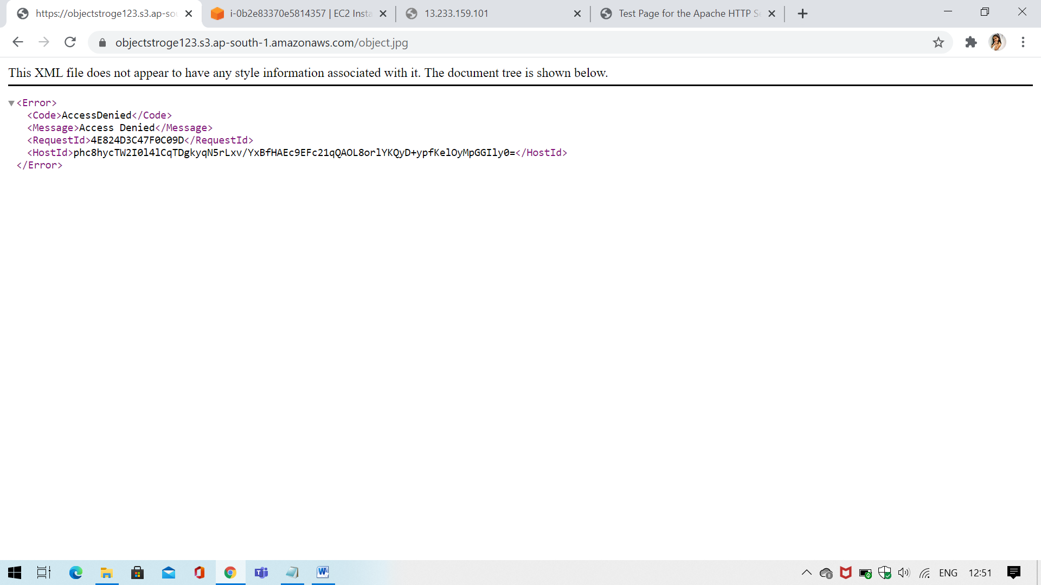

**Step5 – make public**

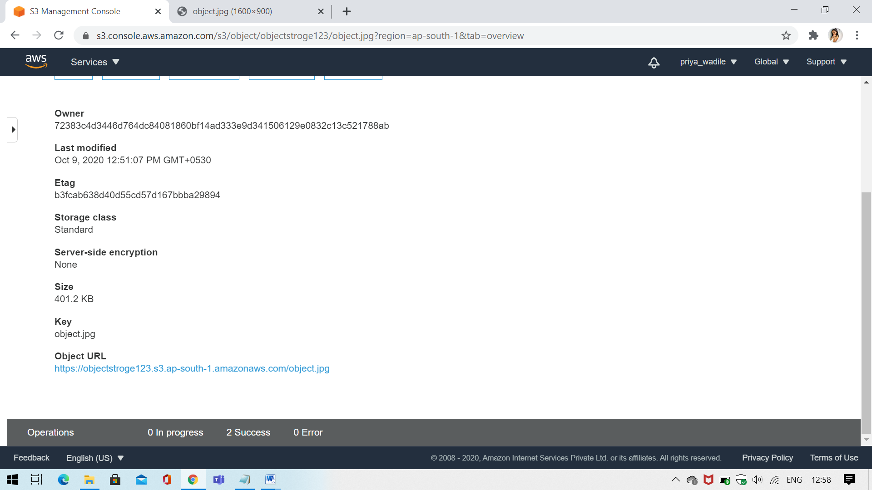

**Step6- Open Image**

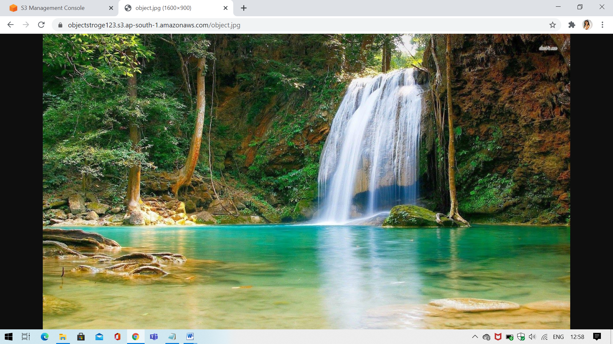

**b. Static web hosting**

**Step1 – Web Host**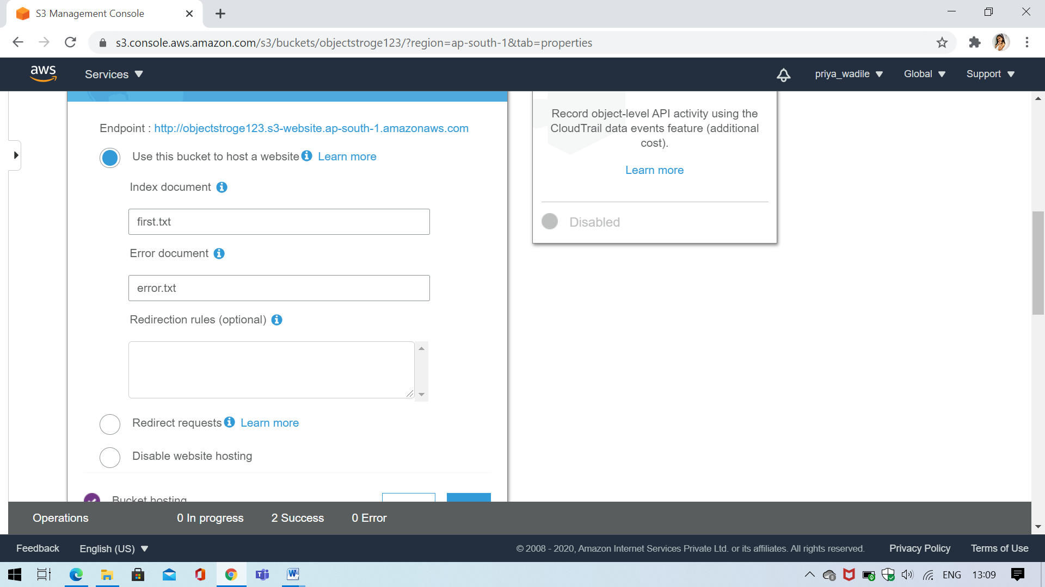

**Step2- Upload .txt file**

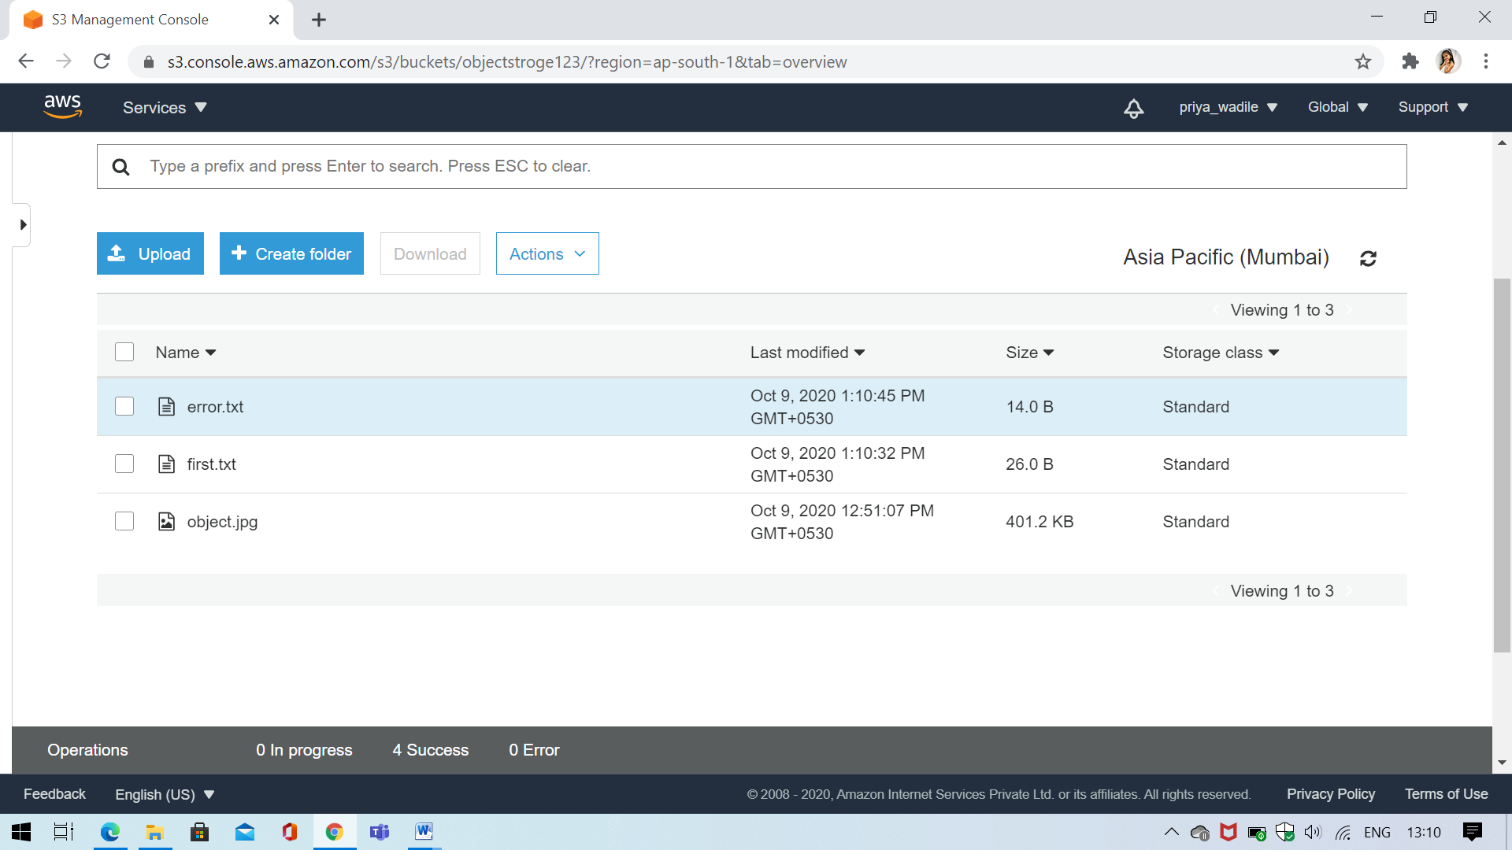

**Step4 – Generate first page**

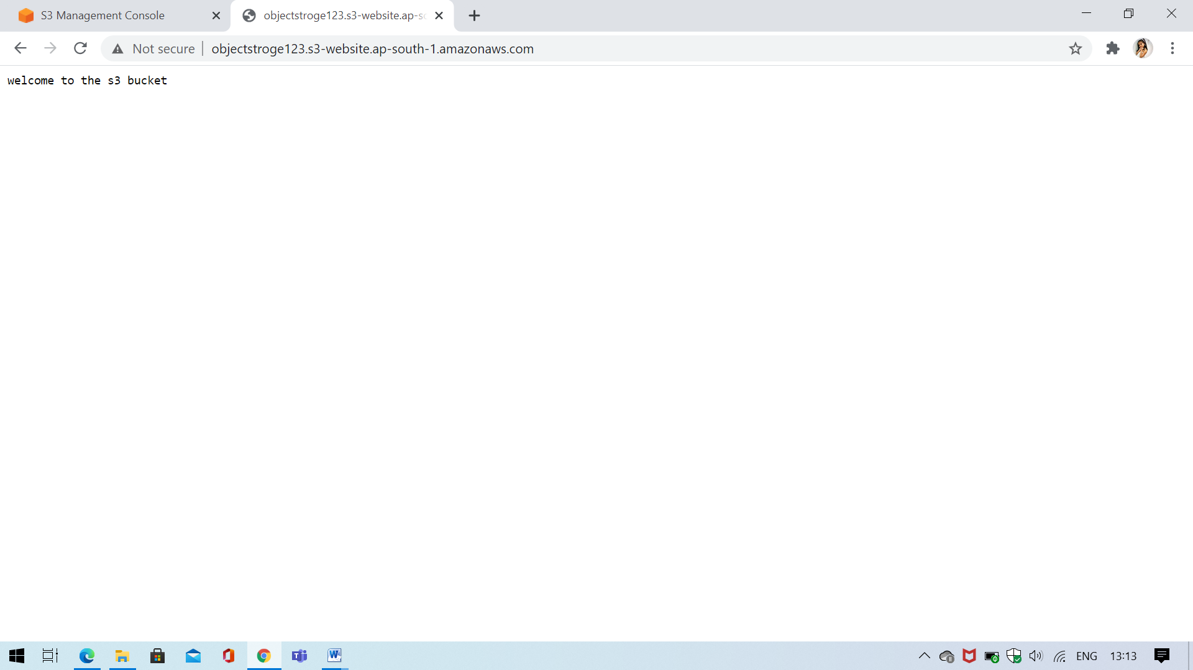

**Step 5 – error page**

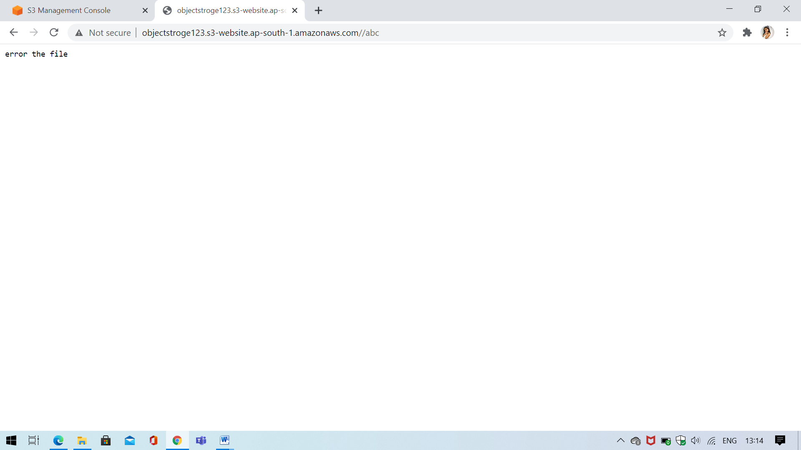

**c. Versioning**

**Step1 – Create S3 bucket**

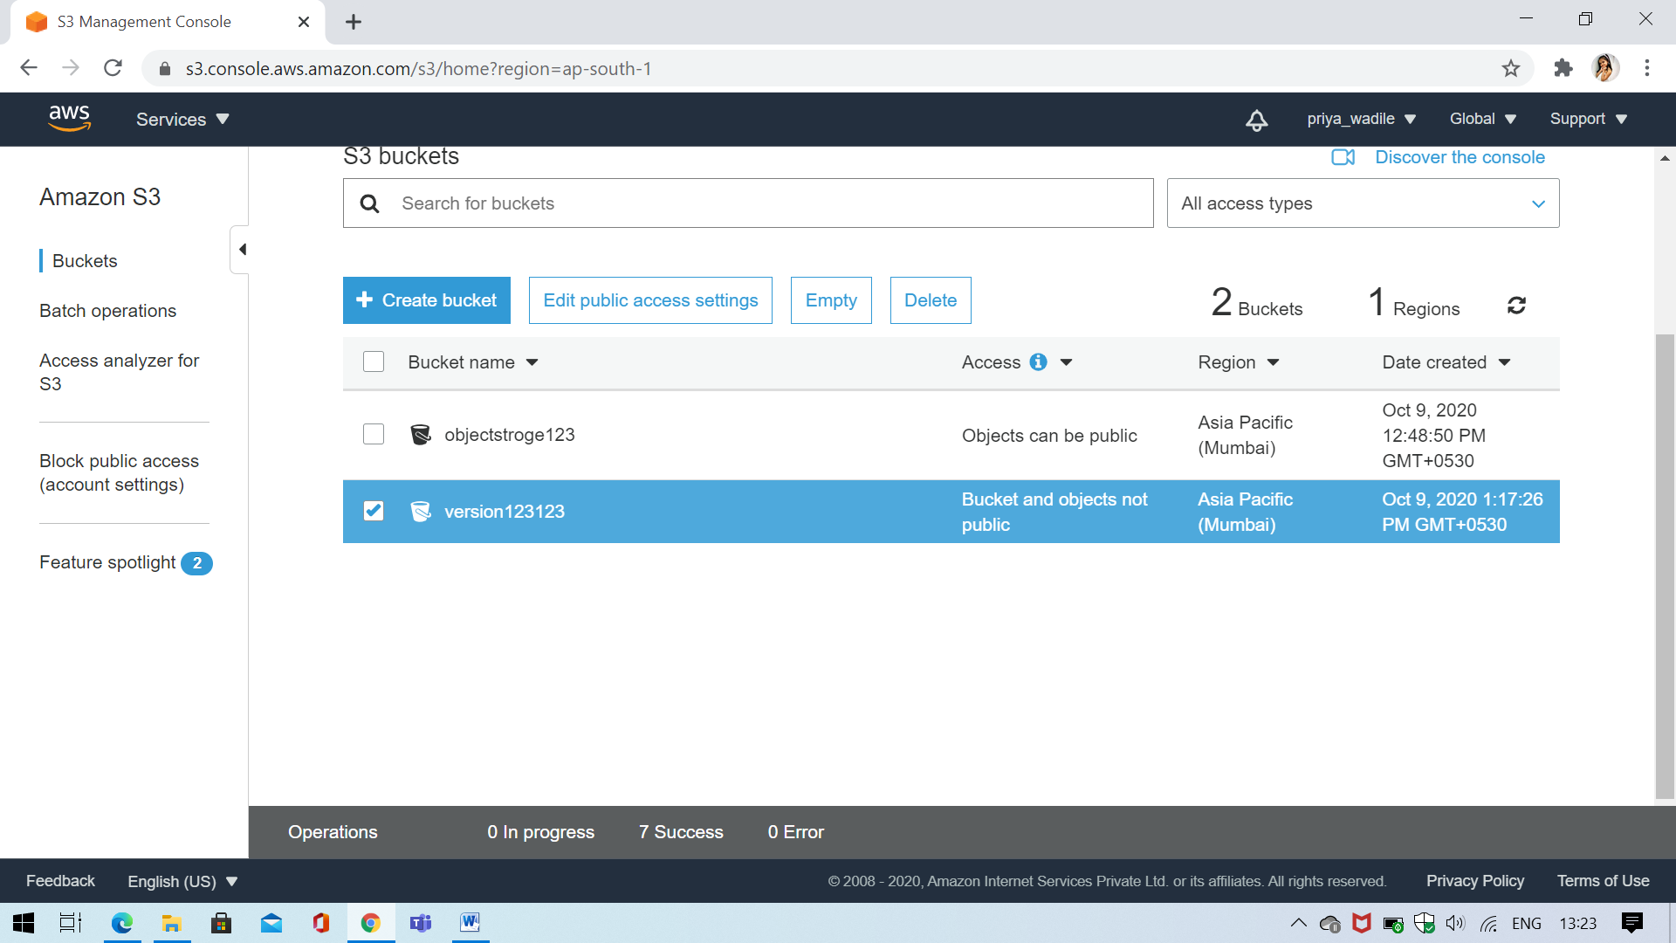

**Step 2- Open Versioning**

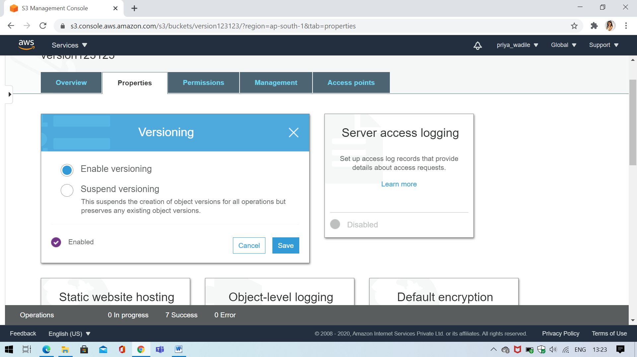

**Stpe3 – upload file**

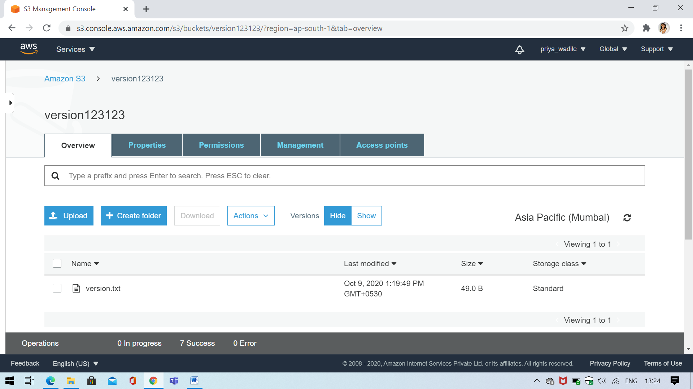**Step 4 – Again .txt upload some change**

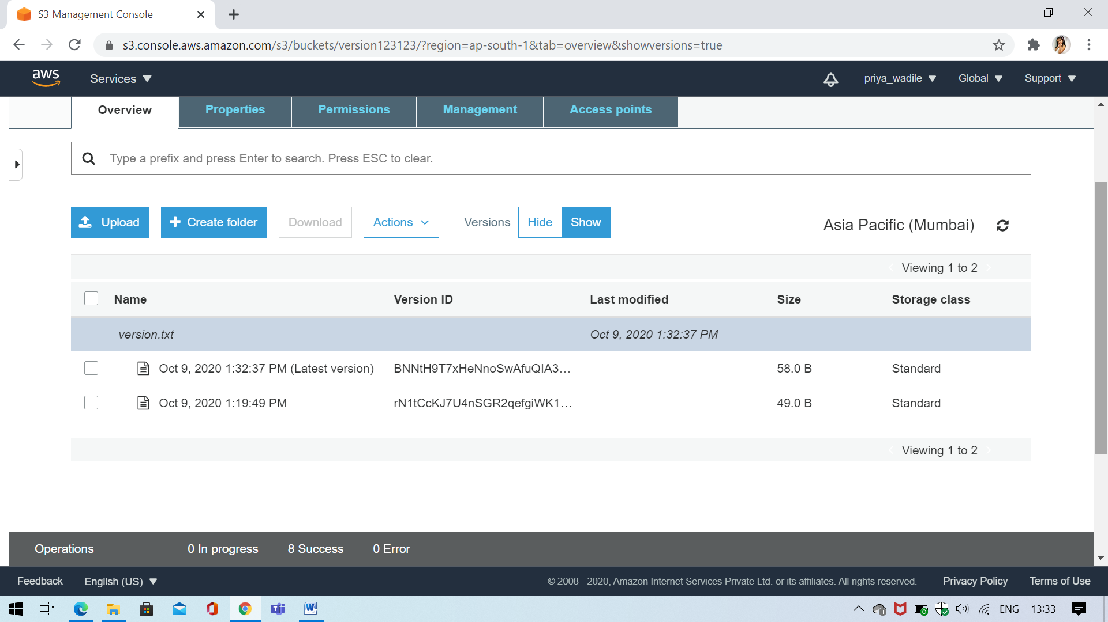

**Step5 - Show**

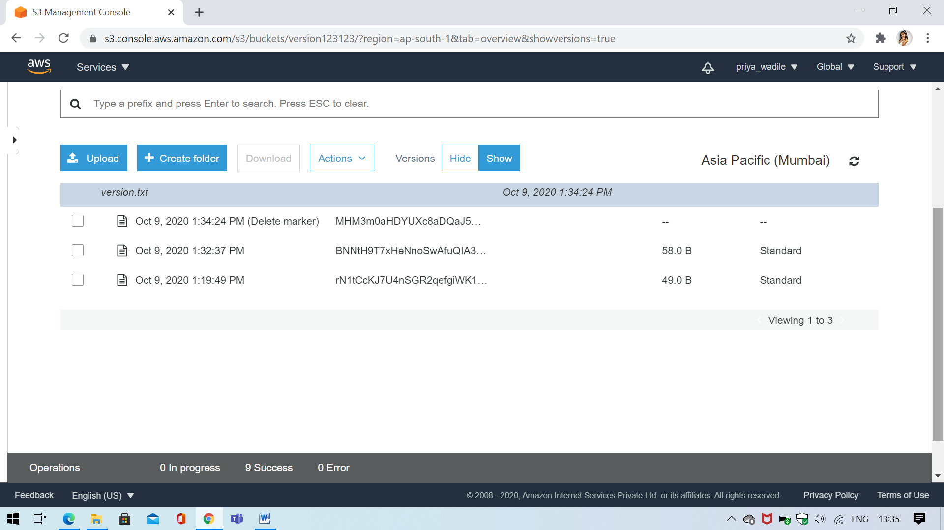

**Step6 – Backup the file**

